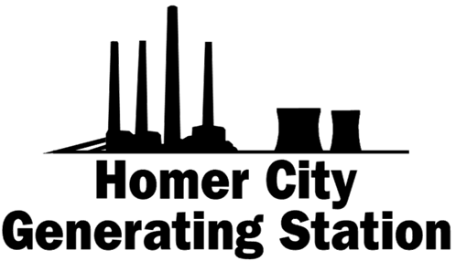

**Homer City Generation, L.P.  
MONTHLY MANAGEMENT REPORT   
June 2019**

Prepared By: Competitive Power Ventures, Inc.

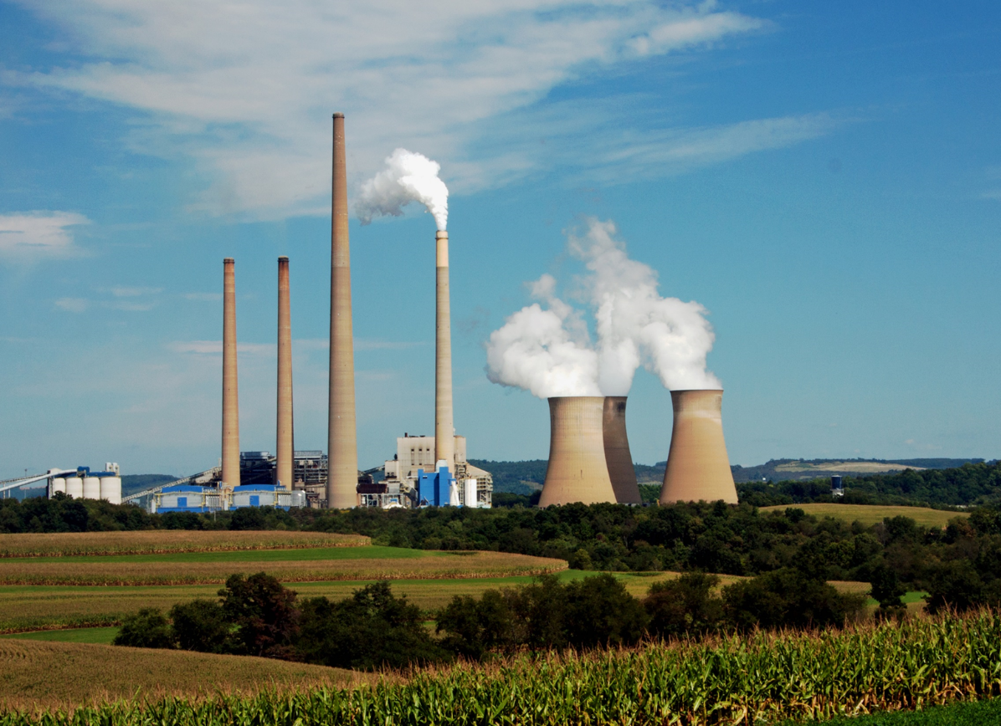

**HOMER CITY Generation, L.P.**

**MONTHLY MANAGEMENT REPORT**

**June 2019**

**A. Key Metrics Scorecard & Executive Summary**

**B. Key Activities for Month**

**C. Operations**

1. **D. Energy Management**

**E. Commercial, Regulatory, Litigation & Community Matters**

**F. Financial Performance**

**A. KEY METRICS SCORECARD & EXECUTIVE SUMMARY**

This report provides an overview of operating and financial results of Homer City Generating Station (“Homer City”) for the period of June 1, 2019 through June 30, 2019 and provides updates on activities up to the date of report issuance. Any reference to “CPV” herein is a reference to “Competitive Power Ventures, Inc.”





Homer City Generating Station’s availability was 94.5% in May (9% favorable to budget). Unit 2 and 3 successfully completed a 74-day and a 20-day planned outage respectively. Unit 1 had 93% availability. The trend of below budget unplanned outage factor has continued through June 2.3% MTD vs 12.0% budget (YTD 4.0% vs 10.7% budget) and all three units are performing better than budget on availability YTD.

Details of Homer City’s operational and financial performance are discussed in this report.

EBITDA for the month of May was $4.4MM unfavorable to budget, primarily attributable to:

* Gross Margin of $1.8MM is $5.7MM unfavorable to budget primarily due to $5.6MM unfavorable Net Energy Margin due to generation being 373 GWh below budget due to reserve shutdown on units 1&3, as a result of power prices $6.42/MWh unfavorable to budget and resulting ATC dark spreads $8.40/MWh unfavorable to budget
* Operating expenses were $8.0MM, $1.3MM favorable to budget due to routine maintenance $0.5MM below budget mainly due to better plant operations, $0.4MM favorable major maintenance (Non POH) due timing, favorable labor of $0.4MM due to lower staffing levels than budgeted, favorable other fixed costs manly due to timing, offset by $0.6MM unfavorable major maintenance (POH) due to timing.



EBITDA YTD May was $19.2MM unfavorable to budget, primarily attributable to:

* Gross Margin YTD of $78.8MM is $20.4MM unfavorable to budget primarily due to $32.8MM unfavorable Net Energy Margin due to power prices $9.27/MWh unfavorable to budget and resulting ATC dark spreads $7.00/MWh unfavorable to budget despite favorable coal prices. Hedge P&L was $15.0MM above budget, partially offsetting the unfavorable Net Energy Margin and unfavorable realized gain on NYISO sales and other revenue of $2.6MM.
* Operating expenses YTD were $82.2MM, $1.2MM favorable labor $1.3MM favorable (lower staffing), consulting costs $1.0M under budget, major maintenance (POH) and contractor costs $0.7MM favorable to budget, $0.5MM favorable routine maintenance and $0.3MM favorable other costs, offset by $3.3MM unfavorable major maintenance (Non POH) due to walking working surfaces, pulverizer repairs and others. $0.7MM of this overrun is timing and funding has been identified from other areas of the budget to offset costs not associated with timing.

Cash Available for Debt Service YTD June was $35.8MM unfavorable to budget primarily attributable to unfavorable EBITDA and unfavorable working capital. Unfavorable working capital was mainly due to coal inventory buildup and cash timing vs budgeted levels, offset partially by favorable other working capital.





**B. KEY ACTIVITIES FOR MONTH**

Activities through the issue date of this report are set forth below:

**Asset Management**

* Arcadis safety audit results revealed no major findings. Arcadis provided positive feedback in many areas. Lock Out Tag Out procedures received special approbations.
* CPV has started the insurance renewal process. Many insurers are expected to increase their participation in the Homer City insurance program. However, premiums are expected to increase by at least 10%.
* Unit 2 and Unit 3 retuned from outage and performed well. The SCR upgrade completed on Unit 2 performed as expected.
* Meetings were held with WSC as part of quarterly touchpoints on the pattern recognition software package. WSC is now providing actionable items towards outage planning.
* The Station is still projecting to complete the year at $1.5M below its approved 2019 budget although extensive repairs required on Unit 3 precipitator duct and ID Fan totaled $425K in unplanned costs.
* Progress continued on reliability improvement projects implementation. Through June 30th, $4.9MM has been spent against a $4.8MM budget approved by the Board of Directors in August 2018. Remaining projected spend to complete reliability efforts is expected not to exceed $385K.

**Energy Management**

* Continued negotiations on ash and scrubber byproducts sales.
* Executed contract with BPRR for increased volume in 2019/2020. The new contract includes performance penalties and premiums.
* Finalizing the Norfolk Southern contract renewal for 7/2019 – 6/2020. Board approved $12.35 per ton, with a minimum of 1MM tons. NS was able to improve to $12.25 per ton, with a minimum volume of 800k tons.

**Accounting**

* 2018 audited financial statements issued April 30, 2019
* Quarterly unaudited financial statements for March 2019 issued in May.
* Continuing to assist the site with PA sales & use exemption form completion.
* 2018 tax compliance ongoing.

**Finance**

* Interest payments were made at month end with a continuation of monthly LIBOR election.
* Provided updated 26-week cash forecast.

**C. OPERATIONS**

|  |  |  |  |  |
| --- | --- | --- | --- | --- |
| **MTD Availability** | **Jun-19** | **Unit 1** | **Unit 2** | **Unit 3** |
| Actual Equivalent Availability Factor | 94.5% | 93.4% | 90.2% | 99.7% |
| Budget Equivalent Availability Factor | 85.8% | 88.0% | 81.3% | 88.0% |
| Actual Equivalent Unplanned Outage Factor | 2.3% | 6.6% | 0.0% | 0.3% |
| Budget Equivalent Unplanned Outage Factor | 12.0% | 12.0% | 12.0% | 12.0% |

|  |  |  |  |  |
| --- | --- | --- | --- | --- |
| **YTD Availability** | **YTD Jun-19** | **Unit 1** | **Unit 2** | **Unit 3** |
| Actual Equivalent Availability Factor | 78.8% | 89.6% | 58.7% | 87.6% |
| Budget Equivalent Availability Factor | 69.5% | 79.2% | 52.7% | 76.6% |
| Actual Equivalent Unplanned Outage Factor | 4.0% | 10.4% | 1.5% | 0.1% |
| Budget Equivalent Unplanned Outage Factor | 10.7% | 12.0% | 8.0% | 12.0% |

|  |  |  |  |  |
| --- | --- | --- | --- | --- |
| **MTD Capacity Factor** | **Jun-19** | **Unit 1** | **Unit 2** | **Unit 3** |
| Actual Capacity Factor | 37.0% | 51.3% | 30.4% | 29.6% |
| Budget Capacity Factor | 41.8% | 31.2% | 26.0% | 66.8% |

|  |  |  |  |  |
| --- | --- | --- | --- | --- |
| **YTD Capacity Factor** | **YTD Jun-19** | **Unit 1** | **Unit 2** | **Unit 3** |
| Actual Capacity Factor | 38.9% | 42.2% | 24.9% | 49.0% |
| Budget Capacity Factor | 56.2% | 62.1% | 40.7% | 65.2% |

|  |  |  |  |
| --- | --- | --- | --- |
| **MTD Safety (NRG EEs only)** | **Jun-19** | **Environmental** | **Jun-19** |
| Recordable | 0 | Notice of Violation | 0 |
| Lost Time Accidents | 0 | Exceedances | 0 |

|  |  |  |  |
| --- | --- | --- | --- |
| **YTD Safety (NRG EEs only)** | **YTD Jun-19** | **Environmental** | **YTD** |
| **Jun-19** |
| Recordable | 2 | Notice of Violation | 0 |
| Lost Time Accidents | 1 | Exceedances | 0 |

**Operations**

Unit 1 was online in June while Unit 2 and Unit 3 were in reserve shutdown for the most part of the month.

* **Unit 1**
  + Unit 1 performed well for most of June with 93.4% availability. The unit suffered nine derates events caused by wet coal in mills and feeders. Total derate time for the month was 75 hours.
* **Unit 2**
  + Unit 2 returned from planned outage on June 3rd. The Unit performed well until June 19th before going into reserve shutdown for 10 days. The unit performed very well while online.
* **Unit 3**
  + Unit 3 was in reserve shutdown for the first 16 days of the month. The unit performed very well while online with a 99.7% availability.
* **Balance of Plant**.
  + 282 corrective maintenance orders were written in June. Of those orders, 173 were completed. 71 additional corrective orders were completed from the backlog, for a total of 244 corrective work orders completed. The backlog is now at 729 workorders or approximately 7 weeks.



**Staffing**

As of June 30th, the station had a total of 194 employees against a budget of 199. Six Union employees were hired to start in July. An offer was made for the Engineering Manager position. There are 15 grievances in various stages.

**Environmental and Safety**

There were no OSHA recordable injuries or lost time accidents in June. The Station completed the month without any environmental exceedances or NOVs. The refuse site permit newspaper notice period was completed in June.

**D. ENERGY MANAGEMENT**

**Spot Market**

For the month of May, Homer City realized ATC power prices were $24.20/MWh ($6.42/MWh unfavorable to budget); TETCO M-3 gas prices were $2.23/MMBtu ($0.05/MMBtu below budget); and NYISO arbitrage was ($4.65/MWh, $3.68/MWh unfavorable to budget).



Temperatures (Philadelphia– Temperatures throughout May were warmer than average, with 14 days significantly warmer, and only a few days below average for the month.

**APRIL TEMPERATURES -PHILADELPHIA**



Above normal temperatures during the month of May, pushed gas injections higher than projected, however Henry Hub forward gas prices for June contracts traded within a narrow band of just $0.12/MMBtu.

May natural gas inventories were 182 BCF higher than year ago inventories, but within the five-year historical range.

 

Net Energy Margin:



May net energy margin was below budget primarily due to generation being 373 GWh below budget due to reserve shutdown on units 1&3 as a result of energy prices $6.42/MWh unfavorable to budget.



**Hedging**

Homer City does not have hedges in place beyond the month of March.



**Coal**

Coal purchases for the month of May consisted of 253k tons from Murray and 5k from local suppliers. Month-end usable inventory for May was 206k tons in the Unit 1&2 pile, equivalent to 15 days burn when running at full load, and 452k tons in the Unit 3 pile, equivalent to 80 days burn when running at full load. Murray had been mining in a high sulfur seam (Unit 3 quality) from mid-March through mid- May, causing the imbalance in the coal piles. Murray has been mining coal suitable for Unit 1 & 2 since mid-May, and the piles are expected to normalize by September.

Deliveries for the Murray 2019/2020 coal contract commenced January 2019. The base price for the coal is $39/ton FOB mine, equivalent to $1.95/MMBtu delivered to the plant. Dark spread sharing starts at 20% for $35/MWh power price to 50% sharing at $40/MWh. Power pricing averaged below $35/MWh for the month, therefore no profit sharing was paid to Murray.

The rail agreement with the BPRR has been finalized. The new agreement includes increased tonnage in 2019/2020, and performance penalties and performance incentives. The Norfolk Southern rail agreement expires June 30, 2019. We have come to agreement on pricing and volume for the next contract year and expect to finalize the agreement in the coming weeks.

BPRR performance has improved with the implementation of sub-contractor, Chemstream, moving trains on site at Homer City, enabling the unloading of a full unit train in 1 day. In addition, the BPRR has leased and put into service a 3rd set of railcars, which has increased service to 12 – 14 trains per month.

The Norfolk Southern continues at a pace of 7 to 8 trains per month and has no desire to increase service into Homer City.

|  |  |  |
| --- | --- | --- |
| **May 2019** | **(tons)** | **$ /mmbtu** |
| **Beginning Inventory** | **463,871** | **$2.50** |
| Receipts |  |  |
| *Murray Term Contract* | *253,210* | *$1.97* |
| *Local Coal* | *5,243* | *$2.15* |
| Plus: Total Receipts | 285,453 | *$1.97* |
| Less: Total Burned | 38,776 | $2.04 |
| **Ending Inventory (tons)** | **683,548** | **$2.04** |
| Less: Blend Coal | **13,536** |  |
| Less: Unusable Inventory | 60,000 |  |
| **Ending Usable Inventory (tons)** | **610,011** | **$2.04** |
|  |  |  |
| **Ending Inventory Value ($)** | **$35MM** | **$2.04** |

** Ending inventory $/mmbtu does not include fuel oil of $0.15/mmbtu. Cost of trucking between coal piles in not includes in cost on receipts above.

NAPP Forward Curve, 12,900 Btu, 4.0 lb. SO2

*As of June 24, 2019*





**Market Update**

NAPP coal prices continue to decline due to lack of new export deals, and weak utility demand. Prompt and Q3 prices are down $0.25 per ton and Q4 is down $0.65 per ton, month over month. Pricing for calendar year 2020 is down $0.25/ton.

**Stockpile**

According to Energy Ventures Analysis (EVA), stockpiles in the NAPP region continue to rise. Coal burns in May were up 1 MM tons over April due to warmer than average temperatures, however utility restocking has outpaced burns. NAPP coal stocks ended May at 18.6MM tons, equivalent to 94 days of burn. EVA defines days burn as the average of the trailing 12 months.

**Export**

May thermal coal exports through the Port of Baltimore were 1.1MM tons, down 32% y-o-y. XCoal was the largest shipper, exporting 0.9MM tons, followed by Javelin exporting .2MM tons (Murray tons). CONSOL exports are sold through XCoal to end-users in China, Europe, and Africa. India was the largest recipient for NAPP exports, receiving 0.8MM tons.



**Expected Generation and Hedged Position and Gross Margin at Risk**



**Liquidity at Risk from Derivatives**

Homer City’s liquidity at risk is zero.

Homer City has capacity sales to PJM and FTRs between Homer City’s LMP and Western Hub. PJM transactions are not subject to MtM margining.

**E. COMMERCIAL, REGULATORY, LITIGATION & COMMUNITY MATTERS**

**Community Matters**

There are no items to report.

**PJM Matters**

*Capacity Construct/Public Policy Senior Task Force:*

There continues to be a delay in FERC issuing a decision in the MOPR/Capacity Construct proceeding.  PJM has informed FERC that it intends to hold the next BRA in August 2019 as planned under the current Tariff rules unless otherwise directed by the Commission. Market participants have also petitioned FERC to further delay the auction until a decision is made in the pending MOPR proceeding.  To comply with PJM’s current path, Homer City is meeting all deadlines necessary to fully participate in the next auction under the current rules.  No decision from FERC is expected until the deadlock is broken, which could occur either through the confirmation of an additional commissioner or the departure of Commissioner LaFleur.

*Energy Price Formation:*

After an extensive stakeholder proceeding, PJM submitted a Section 206 filing with the tariff revisions necessary to implement the energy price formation reforms on March 29, 2019.  Together, these reforms could increase average LMP by as much as $2/MWh.  There is no deadline for FERC to act on a Section 206 filing.

*Carbon Pricing Discussions:*

Stakeholders endorsed a Problem Statement and Issue Charge on Carbon Pricing at the April 25, 2019 Markets and Reliability Committee meeting, beginning a formal stakeholder process in which PJM will conduct a study to explore opportunities to implement carbon pricing in the energy markets, similar to that which is being discussed in New York.

**F. FINANCIAL PERFORMANCE**



**Financial Performance Variance Analysis**



* *Routine Maintenance includes preventive and corrective maintenance as well as forced outage costs. Major Maintenance (POH) are planned outage costs that occur while the units are off-line* *for annual tune-up and/or major overhauls. Major Maintenance (Non-POH) are larger planned maintenance projects that can occur while the units are online. Significant forced outages are also recorded to Non-POH if they are unusual in nature and to maintain comparability to historical reporting for these costs.*



**Financial Performance Variance Analysis – continued**



* *Cash Available for Debt Service = EBITDA less (i) Working Capital and LC Facility Fees and (ii) Capital Expenditures, plus (iii) Cash / Accrual Reconciliation and (iv) Interest Income & Other Fees.*

